Table of Contents
Day 1- ITW LAB 1
1.1 Computer peripheral 1
1.2 System Specification 4
1.3 File Type 5
1.4 Browser and its setting 7
1.41 Bookmark 7
1.42 History Delete 8
1.43 Search Engine Setting 9
1.44 Language Setting 10
1.45 On startup 11
1.46 Advance Search 12
1.47 Popup Blockers 13
14
Day 2 – ITW LAB (Libre office) 14
2.1 Font Type 15
2.2 Font Size 15
2.3Alignment 15
2.4 Bulletin 15
2.5 Page orientation and size setting 15
2.6 Insert image 15
2.7 Flow chart for addition of two numbers 15
2.8 Spell check 15

Day 1- ITW LAB

1.1 Computer peripheral
- Keyboard: A keyboard is an input device that allows users to enter text and commands into a computer system.

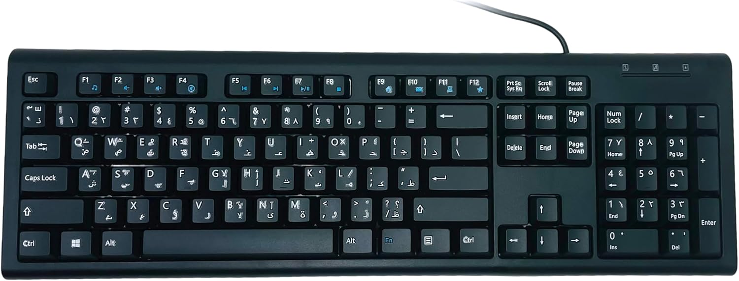
- Mouse: A mouse is an input device that allows users to control the cursor on a computer screen.
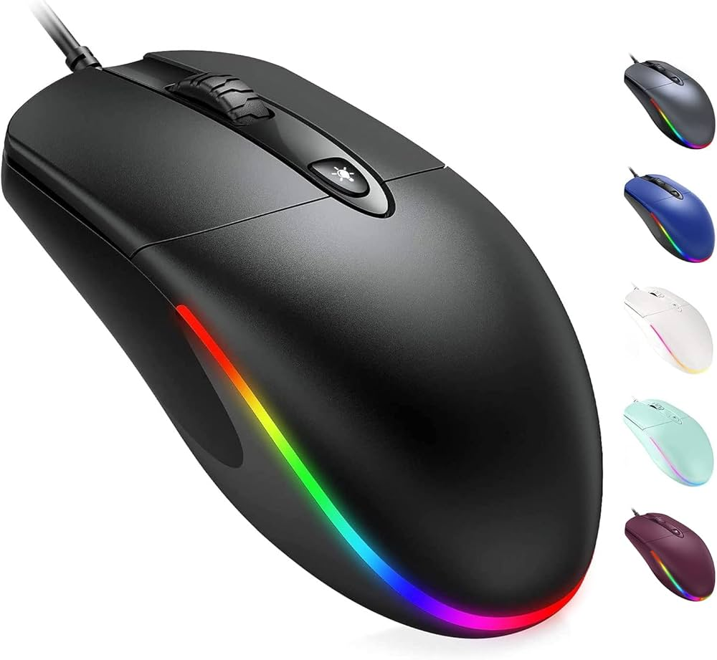
Scanner: A scanner is an input device that allows users to convert physical documents and images into digital files.

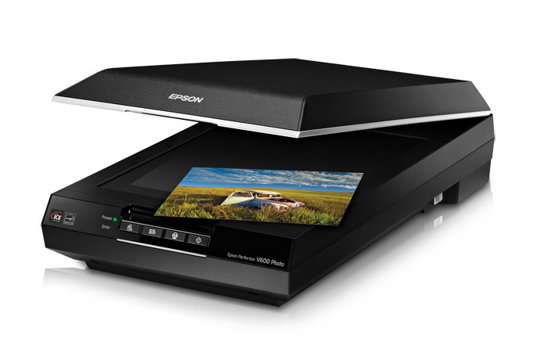
Microphone: A microphone is an input device that allows users to record audio.
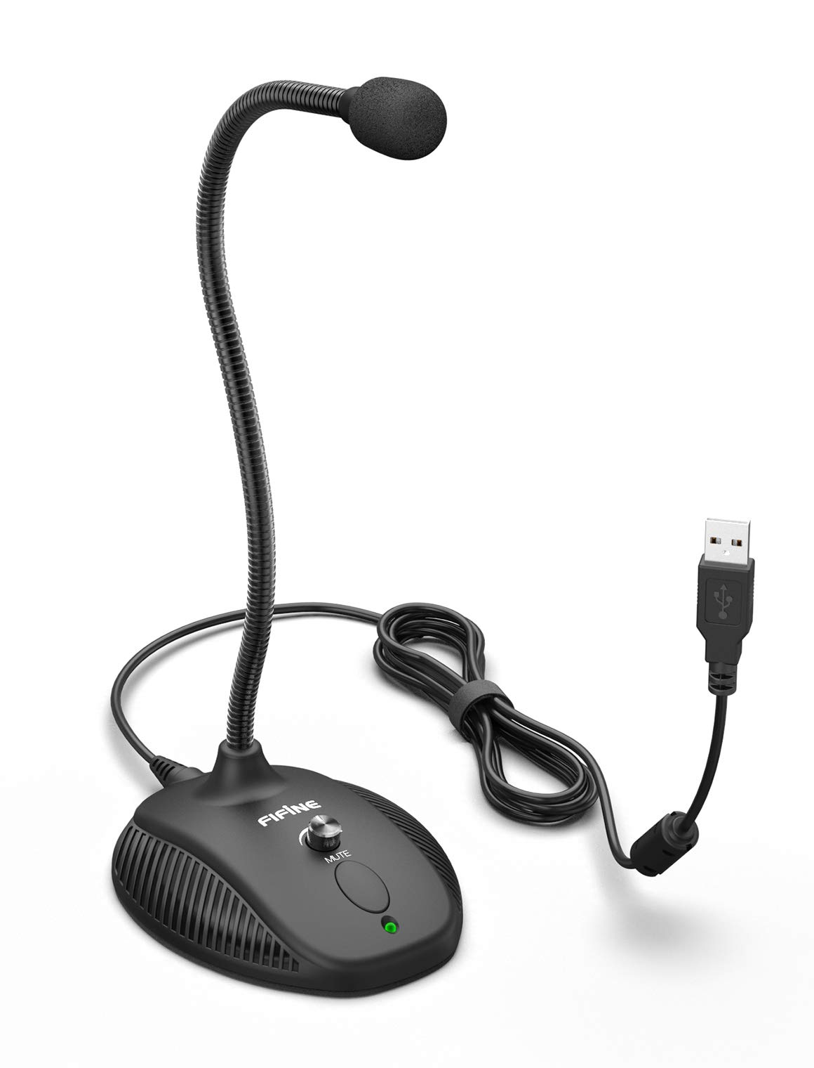
Monitor: It is an output device that displays visual information from a computer system.
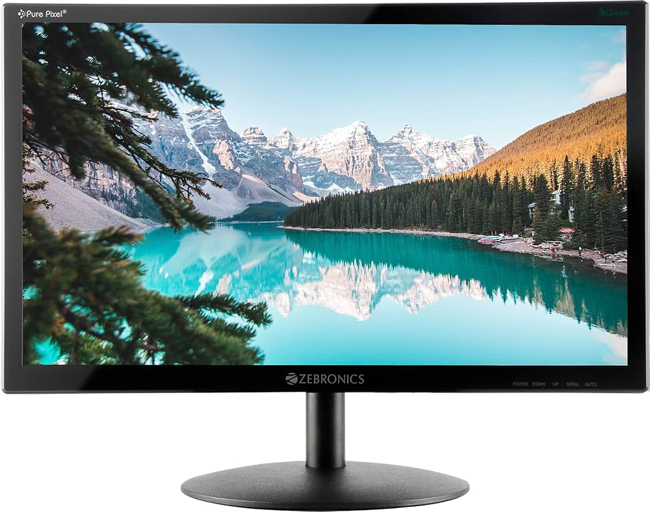
- Printer: It is an output device that produces physical copies of documents or images.
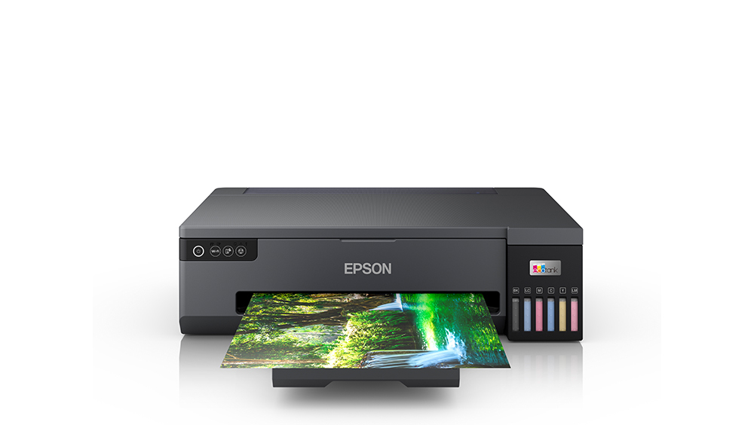
Speaker: It is an output device that produces audio
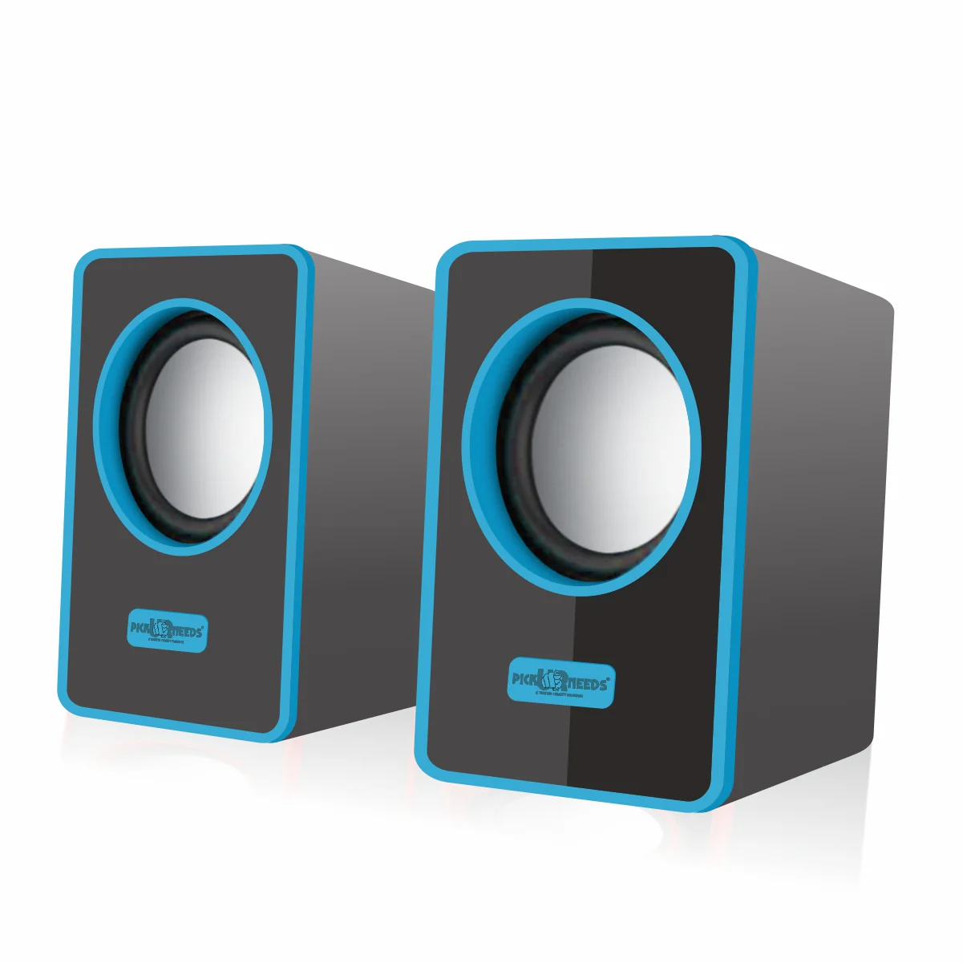
Hard Drive: A hard drive is a storage device that stores data and files on a computer system.
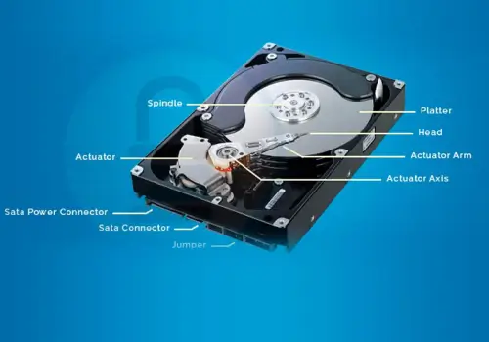

1.2 System Specification

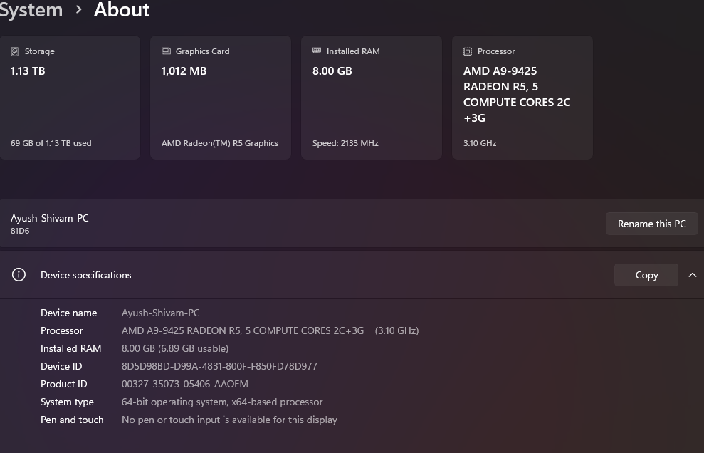

- Processor : AMD A9
- Clock speed : 3.10 Ghz
- RAM : 8 GB
- STORAGE : 1.13 TB
- SYSTEM TYPE : 64 bit operating system
- PEN & TOUCH : No pen & touch inout available
- WEBCAM : No inbuilt webcam
- OPERATING SYSTEM : Windows 11 Home
- OS VERSION : 24H2

1.3 File Type
To Check the type of any file follow these steps:
Step-I: Select the file whose file type you want to check
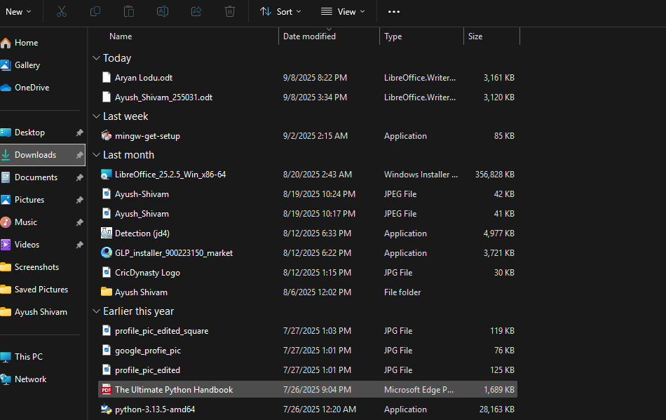

Step II : Right click on that selected file and left click on the properties option
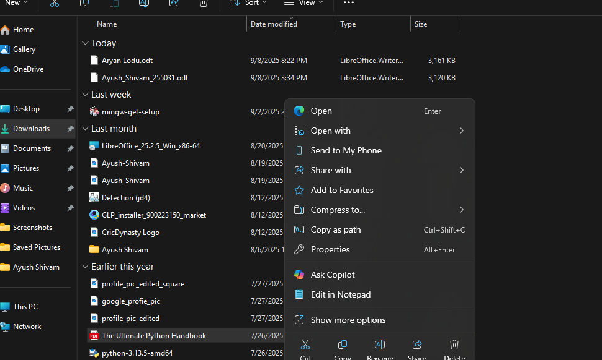
Step III : Now click on Detail option
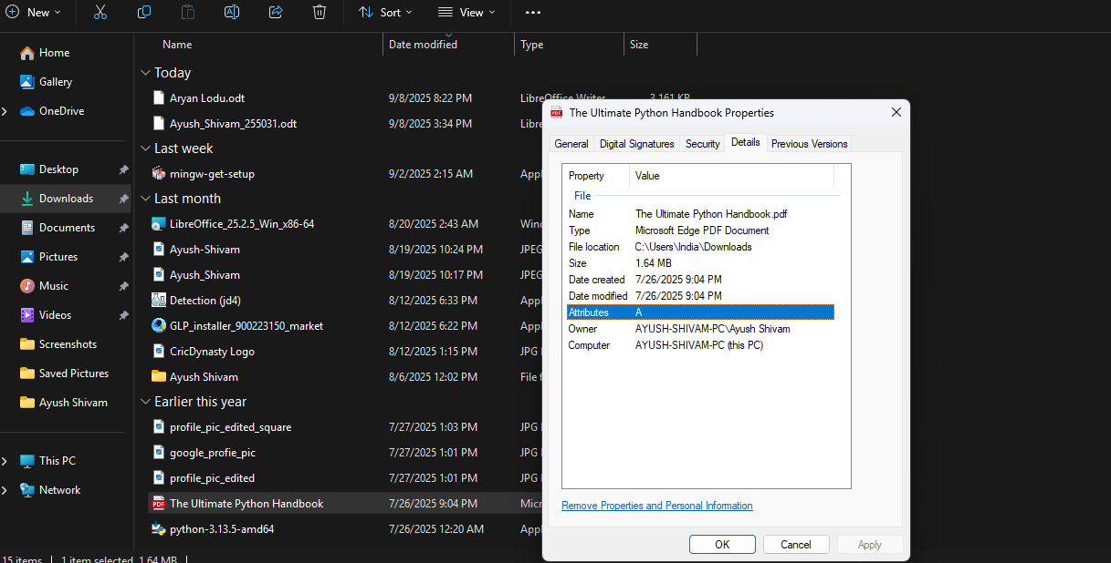

1.4 Browser and its setting

1.41 Bookmark

A bookmark is a place holder for a web page that will allow you quick access to that page instead of having to browse to it or search for it. Instead of typing a web page in Google, clicking the bookmark will direct you to that page immediately.
Step to create a bookmark:
1.Open your browser: and go to the webpage you want to bookmark.
- Locate the address bar: at the top of your browser window.
- Click the star icon: on the far right of the address bar.
- Name your bookmark: in the pop-up window that appears.
- Choose a folder: (like the "Bookmarks Bar" or "Other bookmarks") to save your bookmark in.
- Click "Done" or "Add": to save the bookmark

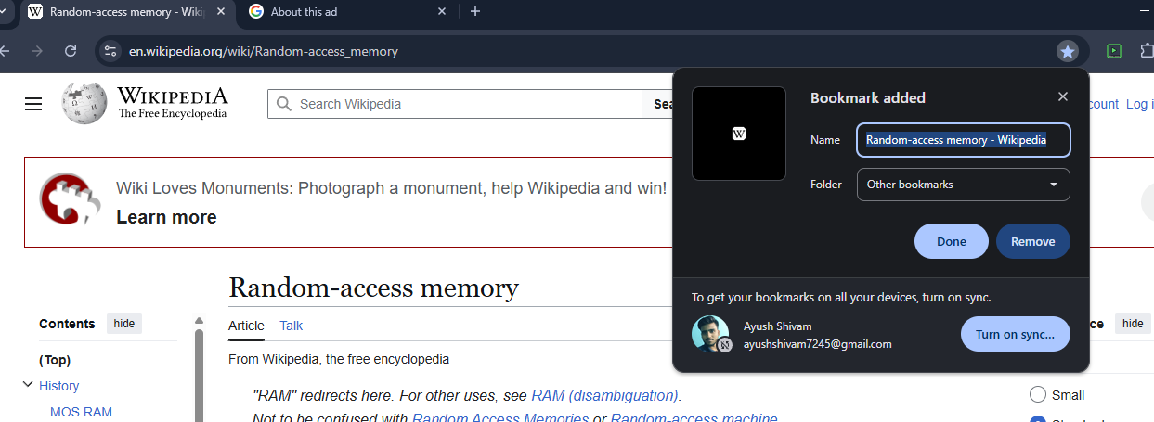

1.42 History Delete
Step to history delete
- Open Chrome and click the More menu (three vertical dots) in the top right corner.
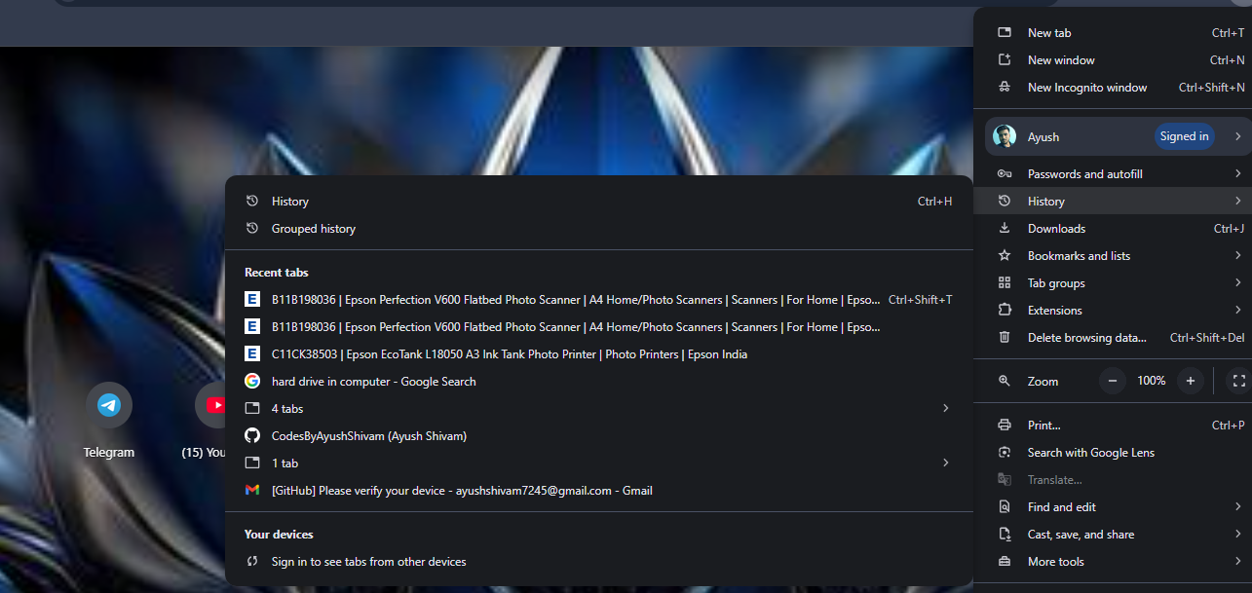
2.Check: the box next to "Browsing history". You can also uncheck other data types you don't want to delete.
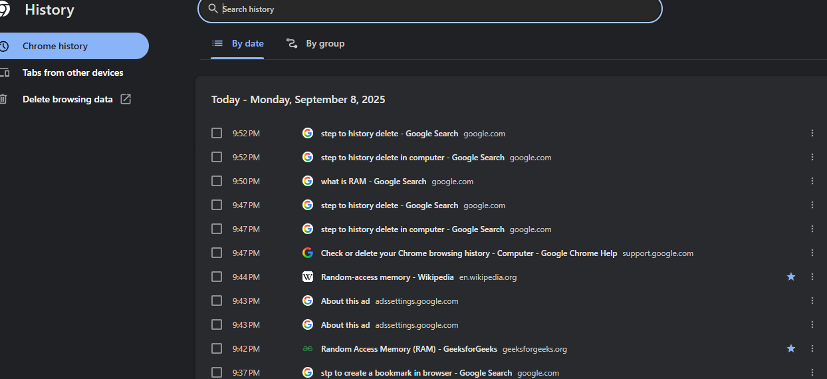
3.Tap: or click "Delete data" or "Clear data" to complete the process.

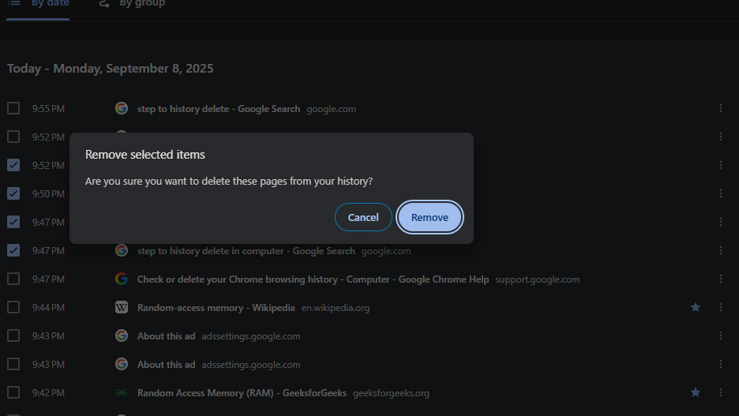

1.43 Search Engine Setting
To change the search engine setting
Step I: Click on the 3 dots icon on the top right of the browser window and click on setting
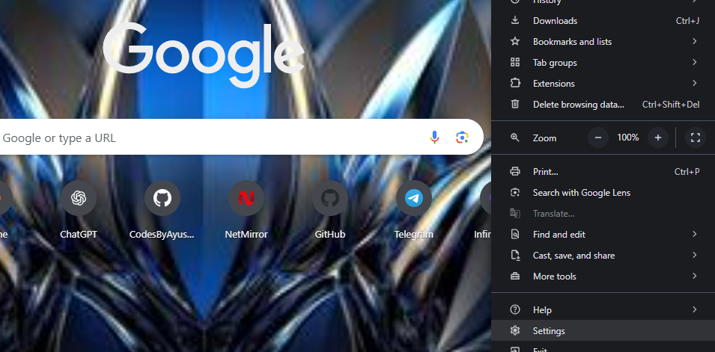

Step II: Click on the search engine option in the left and then select the change button.
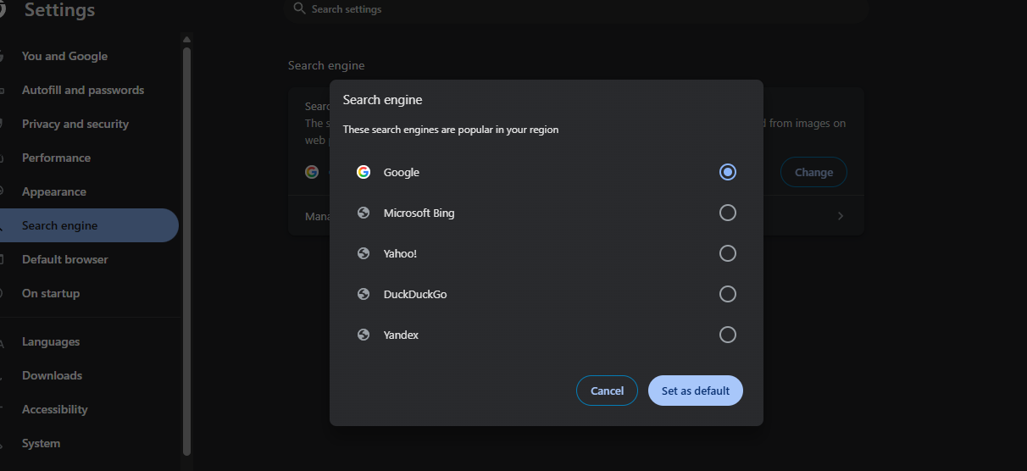
Step III: List of search option will appear. Select the search engine which we want to use and set it as default.

1.44 Language Setting
To change the language of the browser
1.Open Chrome: Launch the Google Chrome browser on your computer.
- Access Settings: Click the three vertical dots (the More menu) in the top-right corner of the browser window.
- Go to Languages: Select Settings from the dropdown menu, then choose Languages from the left-hand menu.
- Add Your Language: Under the "Preferred languages" section, click Add languages.
- Select and Add: From the list of available languages, select the language you want to use, and then click Add.

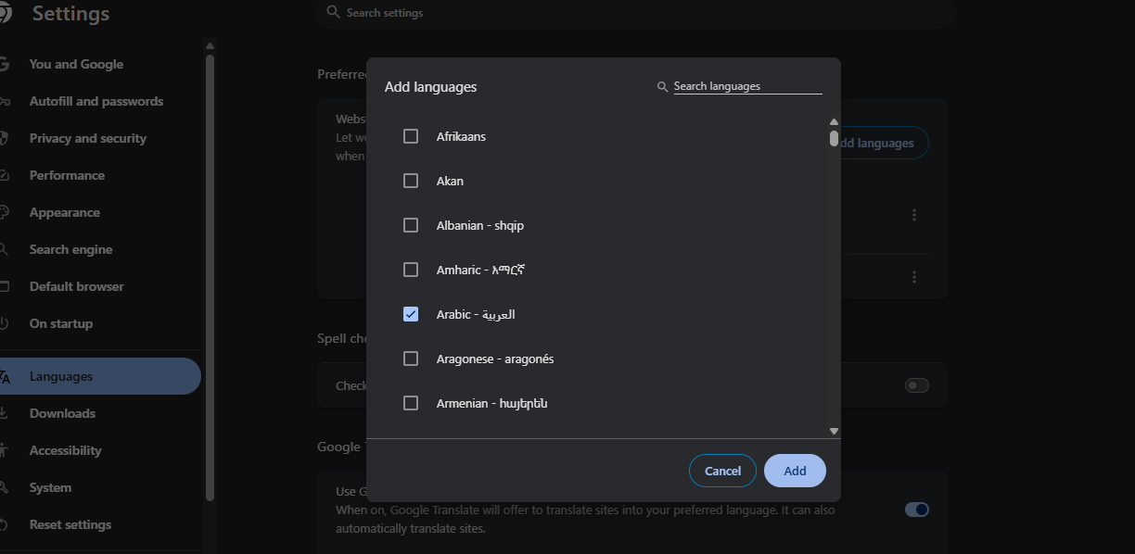

1.45 On startup
- Open Chrome: on your computer.
- Click the More icon (three vertical dots) in the top right corner.
- Select Settings from the dropdown menu.
- On the left-hand side, click on On startup.
- You will see three options:
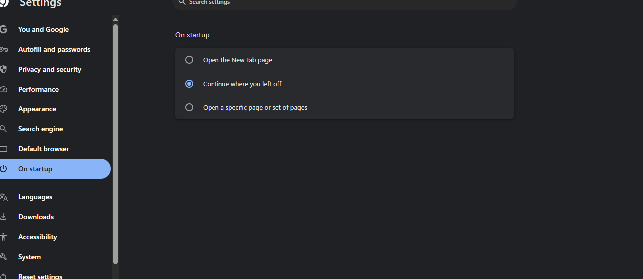

  - Open the New Tab page: This will open a blank new tab each time you launch the browser.
  - Continue where you left off: This will reopen all the tabs you had open when you last closed the browser.
  - Open a specific page or set of pages: Choose this to set a custom startup page or a collection of pages.
- If you choose "Open a specific page or set of pages":
  - You can click Add a new page to type in the URL of a specific website you want to open.
  - Alternatively, click Use current pages to set all the pages you currently have open as your startup pages.
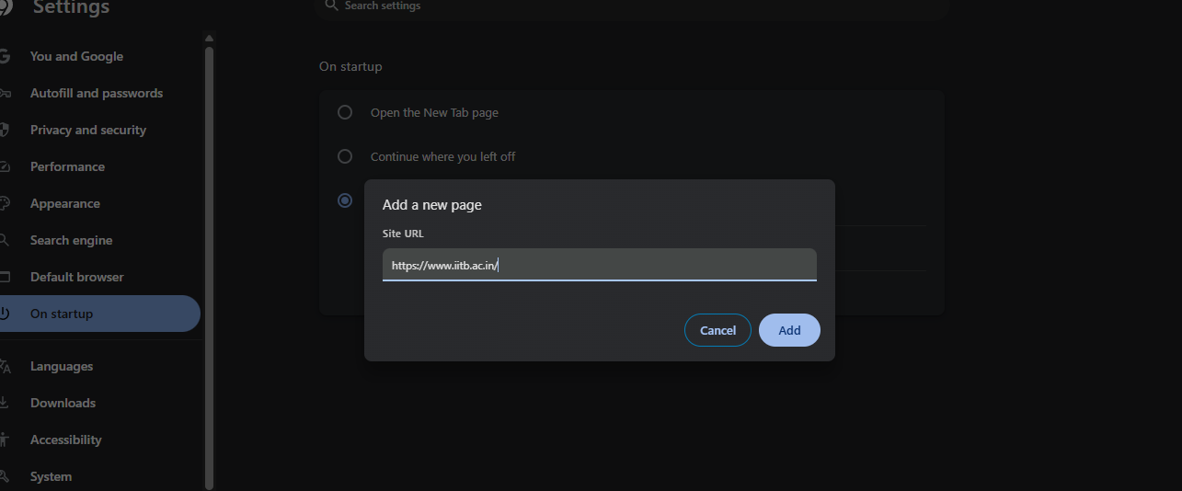

1.46 Advance Search
Google Advanced Search provides tools and operators to refine searches and find more specific, relevant results. It allows users to filter by language, region, date range, file type, and exclude specific terms. You can access the advanced search page at google.com/advanced_search and use its user-friendly interface or type advanced search operators directly into the Google search bar.
To access advanced search tools follow these steps:
Step-I: Open any search engine and search for what you want to search for.
Step-II: Click on the Advanced search option under the tools option in the search bar.
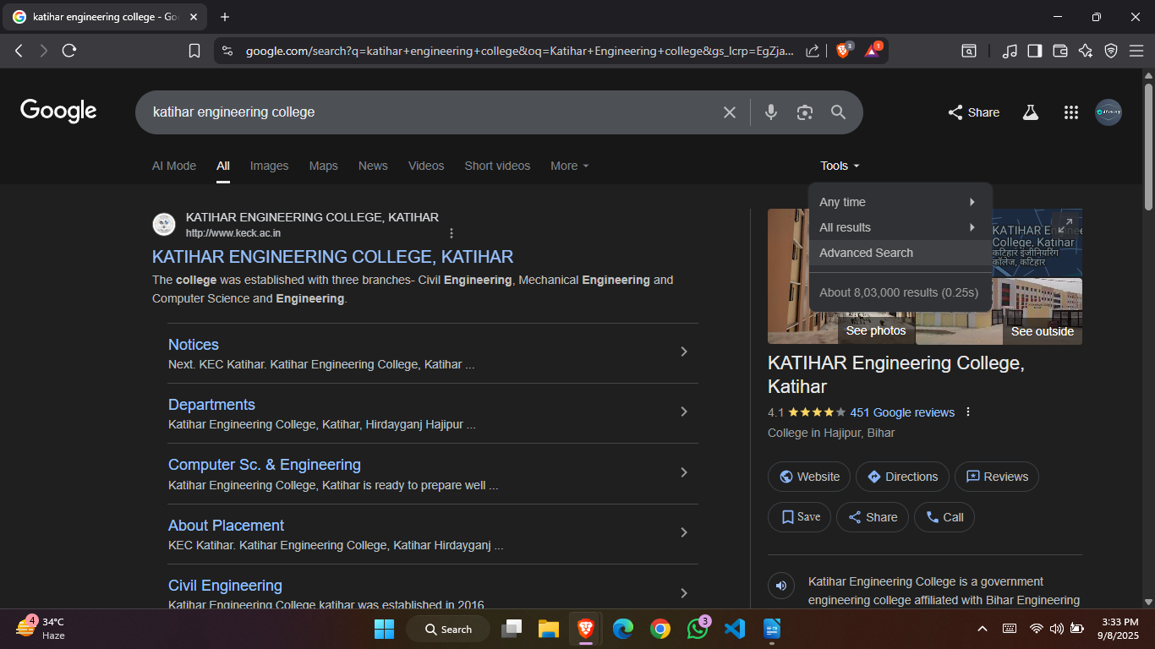
Step-III: Now customize all the search settings as per your use and click the advanced search button.
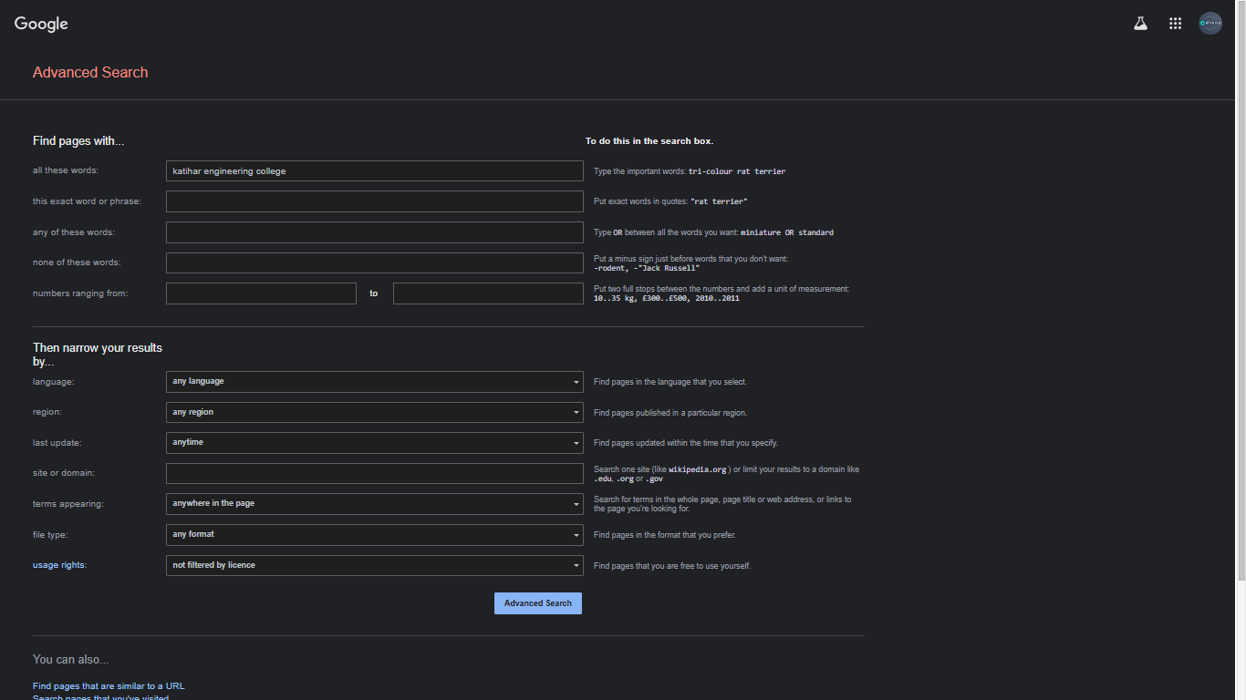

1.47 Popup Blockers

A popup blocker is a feature in web browsers that prevents unwanted, unsolicited windows from appearing on a webpage, typically used to block ads or malware. Most modern web browsers have this feature enabled by default, although users may need to temporarily disable it to access legitimate pop-up windows for important features like downloads or logins. You can usually find and manage pop-up blocker settings within your browser's privacy or site permissions settings.

Day 2 – ITW LAB (Libre office)

2.1 Font Type

2.2 Font Size

2.3Alignment

2.4 Bulletin

2.5 Page orientation and size setting

2.6 Insert image

2.7 Flow chart for addition of two numbers

2.8 Spell check

